<Community Food Wastage Reduction Portal>
Software Requirements Specification

Version 1.0



Group Id: <S26PROJECT51921 (BC220408429)>
Supervisor Name :< Dr. Hasnain Ahmed>

Revision History
Date (dd/mm/yyyy) | Version | Description | Author
Current date | 1.0 | Introduction of the project | Write student(s) id

Table of Contents

- Scope (of the project)
- Functional Requirements Non Functional requirements
- Use Case Diagram
- Usage Scenarios
- Adopted Methodology
- Work Plan (Use MS Project to create Schedule/Work Plan)

SRS Document

Scope of Project:

< This project is helpful for restaurant and Hotels. This project will save a lot of food which is basic need for any living thing a lot of food will be saved. This project encompasses strictly the deliverables outlined herein. Any additional features, tasks, or revisions outside this defined scope require a formal Change Order and may incur timeline adjustments Registration and login for Restaurant owner, Customers and staff and admin. Staff can add food details including type, quantity, expiry time, location, and image. Customers can view and search for available food listings near their location. Admin can manage users, monitor listings, and generate basic reports. We will have a Dashboard which will Display metrics like total food saved, number of donations, and active users. Here is some more details of scope of my project
• User Roles & Access
- Provide secure registration and login for three distinct roles:
  - Donors: Restaurants, hotels, individuals
  - Recipients: NGOs, shelters, volunteers
  - System Admin
- Implement role-based permissions and password hashing.
• Donation Management
- Donors can post surplus food with the following details:
  - Item name
  - Food category (Veg/Non-Veg)
  - Quantity (kg or servings)
  - Location
  - Expiry time
- Listings remain editable until claimed.
• Search & Discovery
- Recipients can find nearby donations using:
  - Map view with GPS-based location
  - City or area search
- Results should display in both map and list views, with filters for distance and time.
• Claiming & Tracking
- Recipients can claim a donation to lock it.
- System tracks donation status through stages:
  - Available → Claimed → Delivered
- Once claimed, the item is locked to prevent duplicate pickups.
• Notifications
- Send automated alerts to nearby NGOs when new donations are posted in their area.
- Allow filters for food type, distance, and quantity.
• Feedback System
- Recipients can rate food quality and hygiene after pickup.
- Ratings are displayed on donor profiles to maintain trust and accountability.
• Admin Controls
- Admins can manage users, listings, and resolve disputes.
>

Functional and non Functional Requirements:

<
Functional Requirements:
• User Management
- Provide secure registration and login for three distinct roles:
  - Donors: Restaurants, hotels, individuals
  - Recipients: NGOs, shelters, volunteers
  - System Admin
- Includes role-based access control and password hashing.
• Donation Listing
- Enable donors to upload surplus food details including:
  - Item name
  - Food category: Veg/Non-Veg
  - Quantity (in kg or servings)
  - "Best Before" timestamp
- Listings are editable until claimed.
• Interactive Map/Search
- Allow recipients to search for available food donations based on:
  - Current geographic location using GPS
  - City or area name
- Results should display on a map and in list view with distance and time filters.
• Claiming System
- Implement a "Claim" feature where a recipient can reserve a listed donation.
- Once claimed, the item is locked to prevent multiple organizations from attempting pickup.
- Auto-release if not confirmed within 2 hours.
• Status Tracking
- Provide a real-time workflow to track donation status through stages:
  - Available → Claimed → Out for Pickup → Delivered
- Status updates are visible to both donor and recipient.
• Notification Engine
- Send automated alerts via email or in-app dashboard notifications to nearby NGOs when a new donation is posted in their area.
- Filters can be set for food type, distance, and quantity.
• Feedback & Rating
- Allow recipients to provide feedback on food quality and hygiene after delivery.
- Ratings are displayed on donor profiles to maintain system trust and accountability.
Non Functional Requirements:
• Performance
- The system should load the main dashboard within 3 seconds on a standard 4G connection.
- It should handle up to 500 concurrent users during peak hours without significant slowdown.
• Scalability
- The backend and database should support scaling to handle 10,000+ restaurants and NGOs as the platform grows.
- Adding new modules should not require rewriting existing code.
• Reliability & Availability
- System uptime should be 99.5%, excluding scheduled maintenance.
- Data backup should run daily with a recovery point objective (RPO) of 24 hours.
• Security
- User passwords must be hashed using bcrypt or a similar algorithm.
- Role-based access control: restaurants, NGOs, and admins should only see relevant data.
- All data transmission must use HTTPS.
• Usability
- The interface should be intuitive enough that a new user can complete registration in under 5 minutes without a manual.
- Mobile-responsive design for use on phones and tablets.
• Maintainability
- The code base should follow MVC architecture and be documented for easy updates.
- Bug fixes and minor updates should be deployable without downtime.
• Compliance
- Comply with local data protection regulations for user data storage.
- Maintain audit logs for all donation and pickup actions.

>

Use Case Diagram(s):

<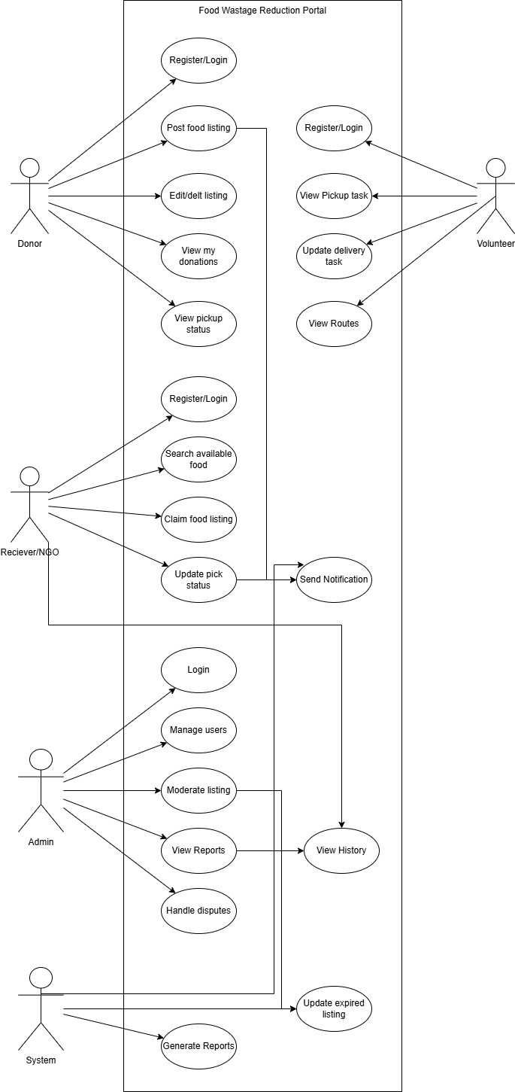>

Usage Scenarios:

<
- Post Food listing
Field | Description
Use Case Title | Post Food Listing
Use Case ID | UC-01
Actor | Donor
Description | Donor adds surplus food details to the system for NGOs to claim.
Actions | Donor logs in  Fills food form with type, quantity, expiry, location, image  Submits form  System validates and saves data  System notifies nearby NGOs
Alternative Paths | If expiry date is invalid, system shows error and asks to re-enter.
Pre Conditions | Donor must be registered and logged in.
Post Conditions | Food listing is saved with status "Available" and visible to receivers.
Author | System Developer
Exceptions | System Developer

- Claim Food Listing
Field | Description
Use Case Title | Claim Food Listing
Use Case ID | UC-02
Actor | Receiver/NGO
Description | NGO views and claims available food listings.
Actions | NGO logs in  Searches available food  Selects a listing and clicks "Claim"  System updates status to "Claimed"  System notifies donor
Alternative Paths | If listing is already claimed, system shows "Unavailable" message.
Pre Conditions | NGO must be logged in and approved by admin.
Post Conditions | Listing status changes to "Claimed". Pickup record is created.
Author | System Developer
Exceptions | Network failure during claim. System rolls back and keeps listing available.

- Update Delivery Status
Field | Description
Use Case Title | Update Delivery Status
Use Case ID | UC-03
Actor | Volunteer / Receiver
Description | User updates pickup and delivery status of claimed food.
Actions | User logs in and opens "My Tasks"  Marks status as "Picked Up" after pickup  Marks status as "Delivered" after delivery  System updates records and dashboard
Alternative Paths | If delivery fails, user can mark as "Cancelled" with reason.
Pre Conditions | Task must be assigned to the user.
Post Conditions | System updates food status and metrics like total food saved.
Author | System Developer
Exceptions | Invalid status update. System rejects and shows error message.

- Manage Users
Field | Description
Use Case Title | Manage Users
Use Case ID | UC-04
Actor | Admin
Description | Admin approves, suspends, or deletes user accounts.
Actions | Admin logs in  Views user list  Selects user and chooses action:  Approve/Suspend/Delete  System updates user status
Alternative Paths | If user is already suspended, option changes to "Activate".
Pre Conditions | Admin must be logged in.
Post Conditions | User status is updated in database.
Author | System Developer
Exceptions | Unauthorized access attempt. System denies and logs event.

- Generate Reports
Field | Description
Use Case Title | Generate Reports
Use Case ID | UC-05
Actor | Admin
Description | Admin generates reports on food saved, donations, and active users.
Actions | Admin logs in  Opens "Reports" section  Selects report type and date range  System generates and displays report
Alternative Paths | If no data found, system shows "No records found".
Pre Conditions | Admin must be logged in.
Post Conditions | Report is displayed and can be exported.
Author | System Developer
Exceptions | Report generation timeout. System shows error and suggests smaller date range.

>

Adopted Methodology
<
After studying Waterfall, Spiral, Agile, and RAD models, I selected the Virtual University Process Model for the Community Food Wastage Reduction Portal. VU itself recommends this model for IT601P because it combines the structure of Waterfall with the flexibility of Spiral, making it suitable for academic projects with clear deliverables and iterative refinement.

The VU Process Model is a hybrid approach that ensures both proper documentation and risk handling. It consists of 6 phases:

1. System Requirement Specification (SRS)

Purpose: Define what the system will do before building it.
Activities for my project:
- Conducted interviews with mock donors, NGOs, and volunteers to understand food donation problems.
- Documented functional requirements: user registration, food listing, claiming, notifications, delivery tracking and admin reports.
- Documented non-functional requirements: usability, response time <3s, data security, availability.
- Created use case diagrams and detailed use case descriptions for all actors.

Deliverable: SRS document. This phase ensures no scope creep later and forms the contract for the project.

2. Design Phase

Purpose: Define how the system will work.
Activities for my project:
- Database Design: Created ER diagram and normalized tables for Users, Food Listings, Claims, transactions.
- System Design: Developed DFD Level 0 and Level 1, Sequence Diagrams for "Post Food" and "Claim Food" flows.
- UI/UX Design: Designed wireframes for donor dashboard, NGO dashboard, and admin panel in draw.io.
- Architecture: Chose 3-tier architecture - Presentation, Business Logic, Database layer.

Deliverable: Design document with all diagrams. This phase reduces development errors by planning before coding.

3. Development Phase

Purpose: Convert design into working code.
Activities for my project:
- Used PHP/Laravel for backend and HTML/CSS/JS for frontend.
- Developed modules iteratively: first User Management, then Food Listing, then Claiming, then Reporting.
- Followed modular coding standards for maintainability.
- Integrated database with backend using MySQL.

Deliverable: Working software prototype. Each module was tested after development before moving to the next.

4. Test Phase

Purpose: Verify the system works as per SRS and is error-free.
Activities for my project:
- Unit Testing: Tested each function like login, post listing, claim food individually.
- Integration Testing: Checked data flow between modules.
- System Testing: Tested full workflow from donor posting to NGO delivery.
- User Acceptance Testing: Got feedback from 3 mock users to check usability and fix issues.

Deliverable: Test cases and test report. Bugs found were fixed before final submission.

5. Final Report

Purpose: Document the entire project for evaluation and future maintenance.
Activities for my project:
- Compiled all chapters: Introduction, Literature Review, System Analysis & Design, Implementation, Testing and Conclusion.
- Included diagrams, screenshots, source code snippets, and user manual.
- Ensured formatting follows VU guidelines.

Deliverable: Complete project report in MS Word/PDF format.

6. Presentation and Viva

Purpose: Demonstrate the system and defend the project logic.
Activities for my project:
- Prepared PowerPoint slides covering problem, solution, methodology, and demo.
- Prepared for viva questions on database design, use cases, and why VU model was chosen.
- Created a working demo video for submission.

Deliverable: Presentation slides and demo video.

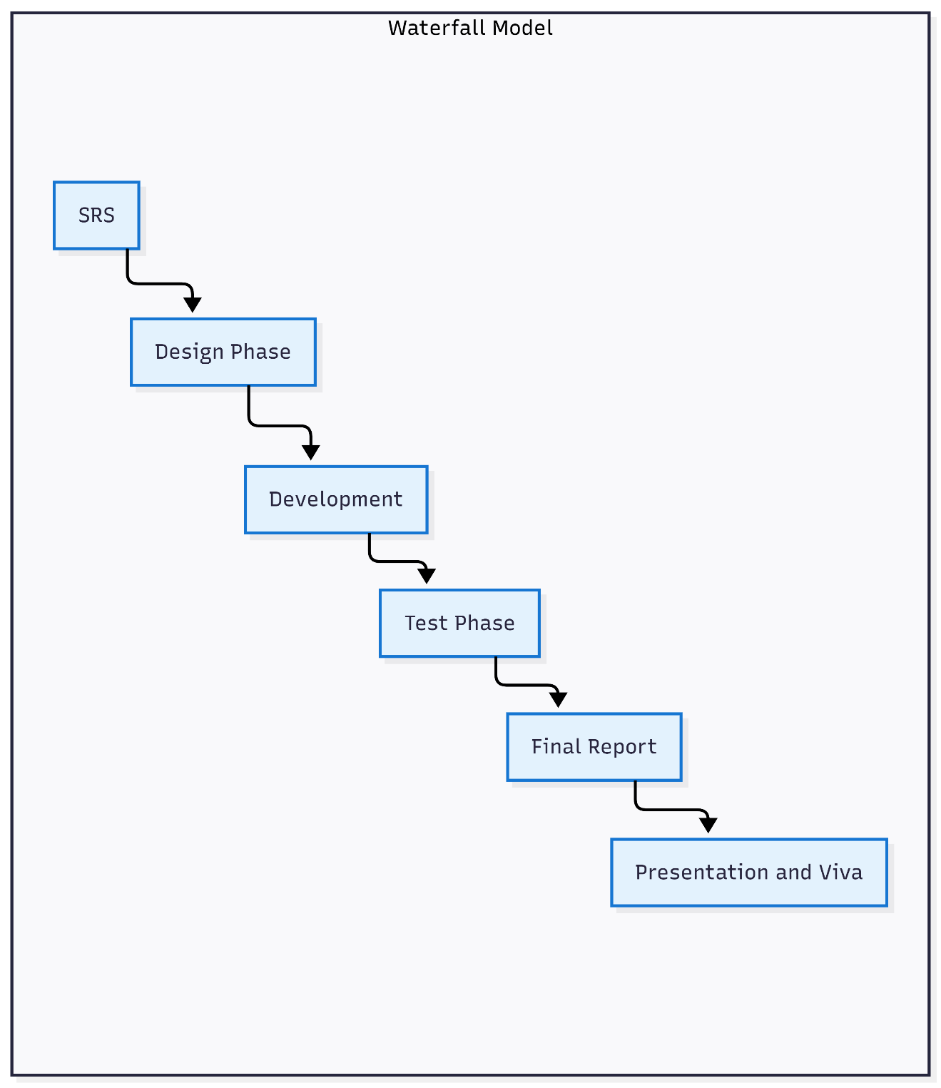 >

Work Plan (Use MS Project to create Schedule/Work Plan)
<




